Project Document

Project Aim

The aim of this project is to develop an intelligent CV and interview analysis system that supports recruitment by combining Natural Language Processing, graph-based candidate profiling using Neo4j, and API-based behavioral analysis. The system is designed to extract and structure candidate information from CVs, generate meaningful summaries, support dynamic recruiter queries, and provide supplementary interview insights through facial emotion recognition and voice stress detection. The overall goal is to improve the efficiency, scalability, and quality of candidate evaluation in modern recruitment environments.

Project Objectives

The objectives of the project are:
1. To design and implement a CV upload and parsing mechanism that can process documents in multiple formats such as PDF and DOCX.
2. To apply Natural Language Processing techniques to extract key candidate information, including education, work experience, skills, certifications, and achievements.
3. To structure the extracted information into a Neo4j graph database for efficient relationship modeling and querying.
4. To generate automated candidate summaries that highlight the most relevant qualifications for recruiter review.
5. To develop a filtering and search interface that allows recruiters to shortlist candidates based on defined criteria.
6. To integrate an API-based Facial Emotion Recognition component to provide supplementary emotional indicators during interview analysis.
7. To integrate an API-based Voice Stress Detection component to provide supplementary vocal stress indicators during interview analysis.
8. To evaluate the effectiveness of the system in terms of CV parsing accuracy, graph-based retrieval, candidate filtering, and overall recruitment decision support.

Project Methodology

The project follows a modular and iterative system development methodology. Each major component is developed and tested independently before being integrated into the full platform. The methodology includes the following stages:

1. Literature Review

A review of existing studies is conducted to understand prior work in CV parsing, recruitment automation, graph-based candidate modeling, facial emotion recognition, and voice stress analysis. This helps identify research gaps and define the system design.

2. Data Collection and Preparation

Relevant datasets are selected for CV processing and interview analysis. Public resume datasets and synthetic CV samples are used for testing the CV parsing module. Interview-related image and audio inputs are prepared for use with the behavioral analysis APIs.

3. CV Parsing and Information Extraction

Candidate CVs are uploaded and converted into machine-readable text. NLP techniques are then applied to extract structured details such as personal information, education, skills, and work experience.

4. Graph-Based Candidate Modeling

The extracted CV data is transformed into nodes and relationships and stored in Neo4j. This allows candidate information to be explored through graph-based queries and recruiter filtering.

5. Candidate Summarization

The structured profile data is used to generate concise summaries that help recruiters review applicants more efficiently.

6. API-Based Interview Analysis

Facial Emotion Recognition and Voice Stress Detection are integrated through external APIs. These are not treated as the major research component of the project, but as supportive services that provide additional behavioral indicators during interview review.

7. System Integration

All modules are connected through a backend architecture so that CV parsing, graph storage, candidate filtering, and interview analysis work together as a single platform.

8. Evaluation

The system is evaluated using appropriate measures such as precision, recall, F1-score, query relevance, response time, and recruiter-oriented usability indicators. Comparisons are also made with baseline approaches such as keyword-based screening.

Technologies Used

The main technologies used in the project are listed below.

Natural Language Processing and Text Processing

- Python
- SpaCy
- NLTK
- Regular Expressions
These are used for text preprocessing, named entity extraction, and candidate information analysis.

Document Processing

- PDF parsing libraries
- DOCX processing libraries

These are used to read and extract text from uploaded CV documents.

Graph Database

- Neo4j
- Cypher Query Language

These are used to model candidate profiles as graphs and support relationship-based recruiter queries.

Backend Development

- Python Flask

This is used to manage application logic, API communication, and system integration.

Frontend Development

- PHP
- HTML
- CSS
- JavaScript

These are used to build the recruiter interface for CV upload, filtering, and profile review.

Visualization

- Neo4j Bloom
- D3.js

These are used for graph visualization and candidate relationship display.

Facial Emotion Recognition

- External Facial Emotion Recognition API

This is used to obtain emotion-related outputs from interview image or video input.

Voice Stress Detection

- External Voice Stress Analysis API

This is used to obtain stress-related outputs from candidate speech during interviews.
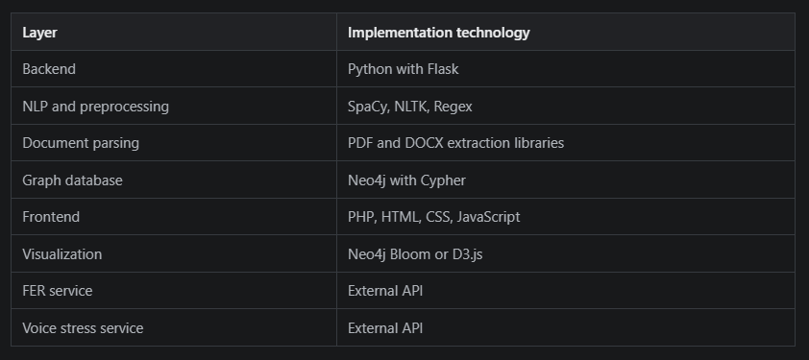

Anuruddha | Mahima
Backend – NLP Model – PDF Extraction | Front End – Basic Interfaces
Backend – Neo4J Mapping | Face Recognition API
Backend – NLP Finetunning for larger count PDF managing | Voice Recognition API
Neo4j Screening | Result Analysis Window

